**Student Project Submission Form**

To complete this assessment, you need to upload the site you created to a web server. You also need to submit a ZIP file that includes all files (i.e., images, other media) used to create your website and a completed copy of this form.

**Student ID:** 001199141

**Date:** April 20, 2024

**URL:** [Wyoming (rf.gd)](http://wgutask2d277ralphmoore.rf.gd/) <http://wgutask2d277ralphmoore.rf.gd/>

**Screen shots of live website as viewed with Firefox browser on** **April 20, 2024.**

1. **Index Page - Home**

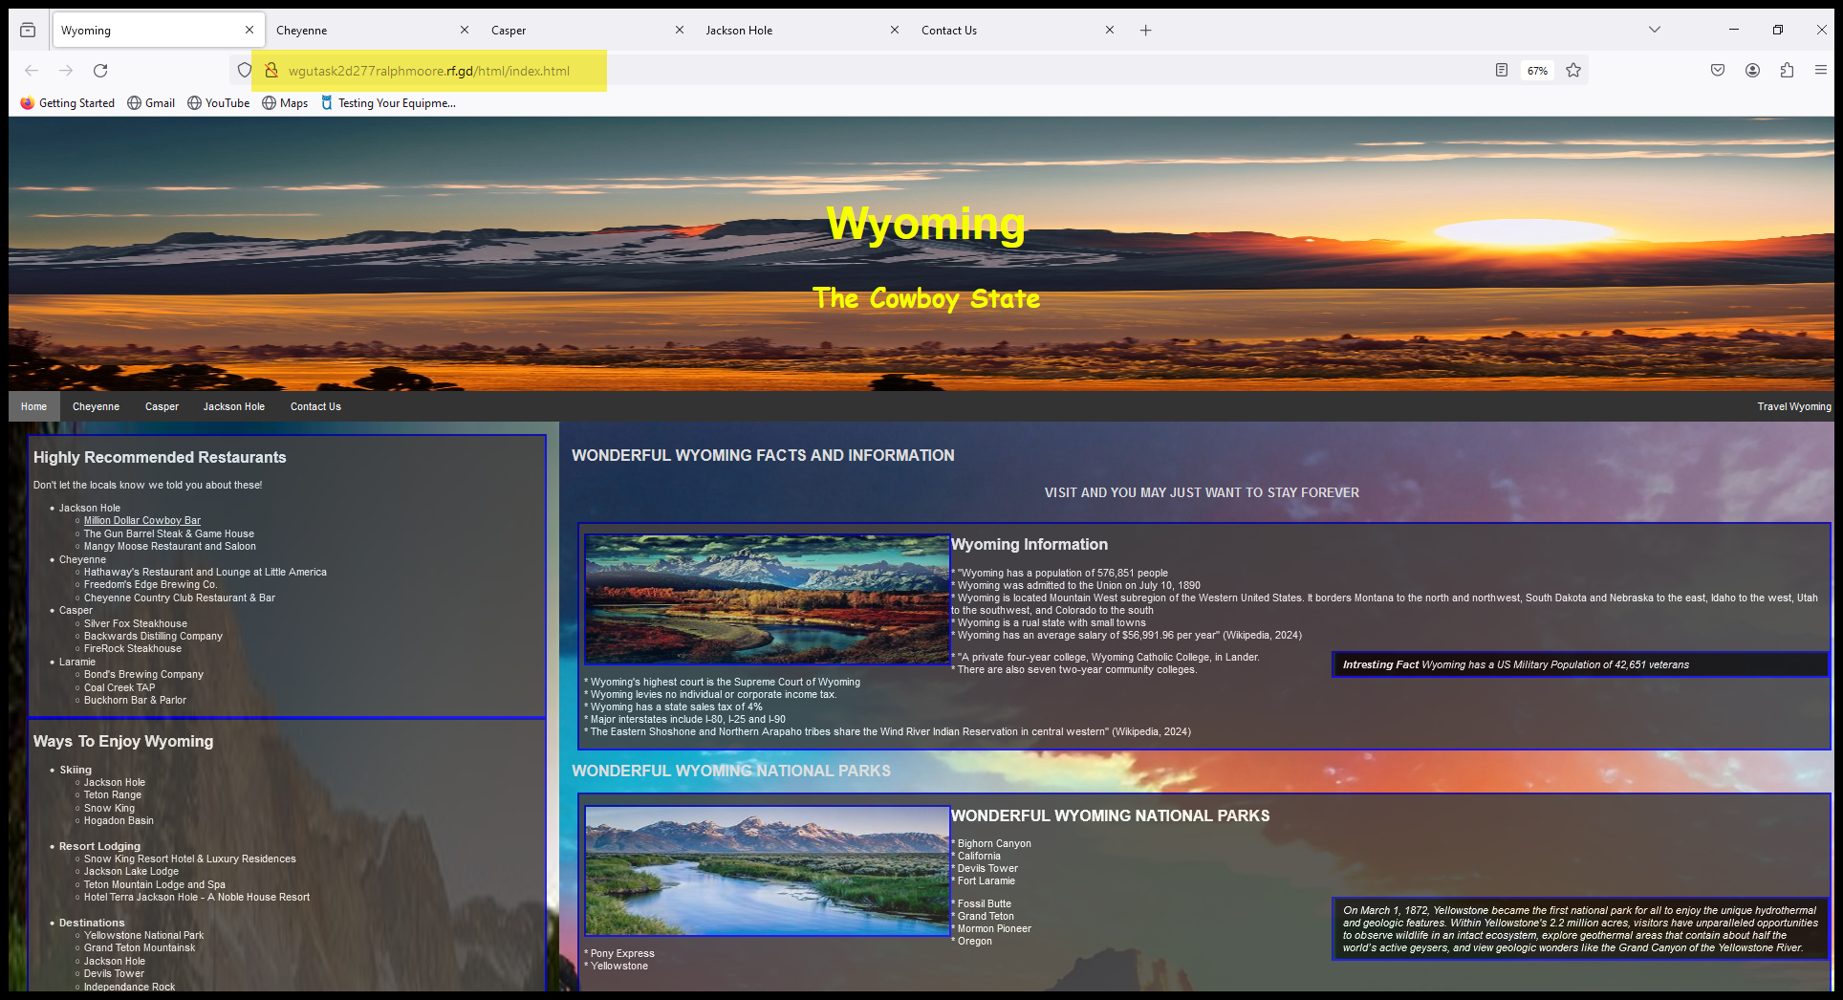

1. **Cheyenne – State Capital**

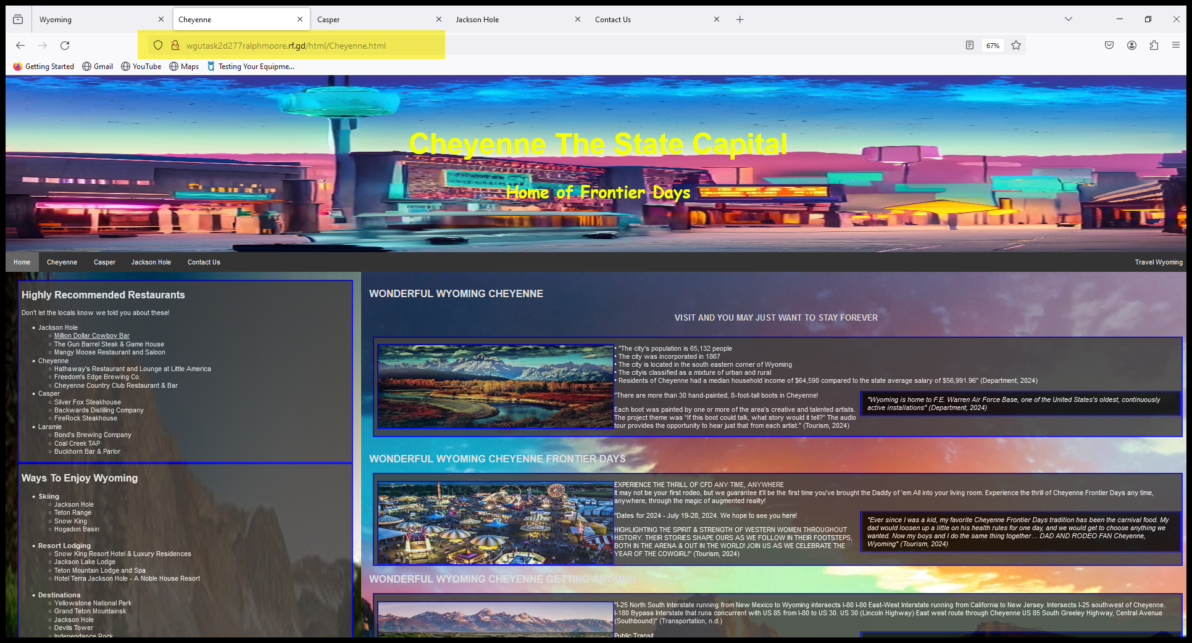

1. **Casper**

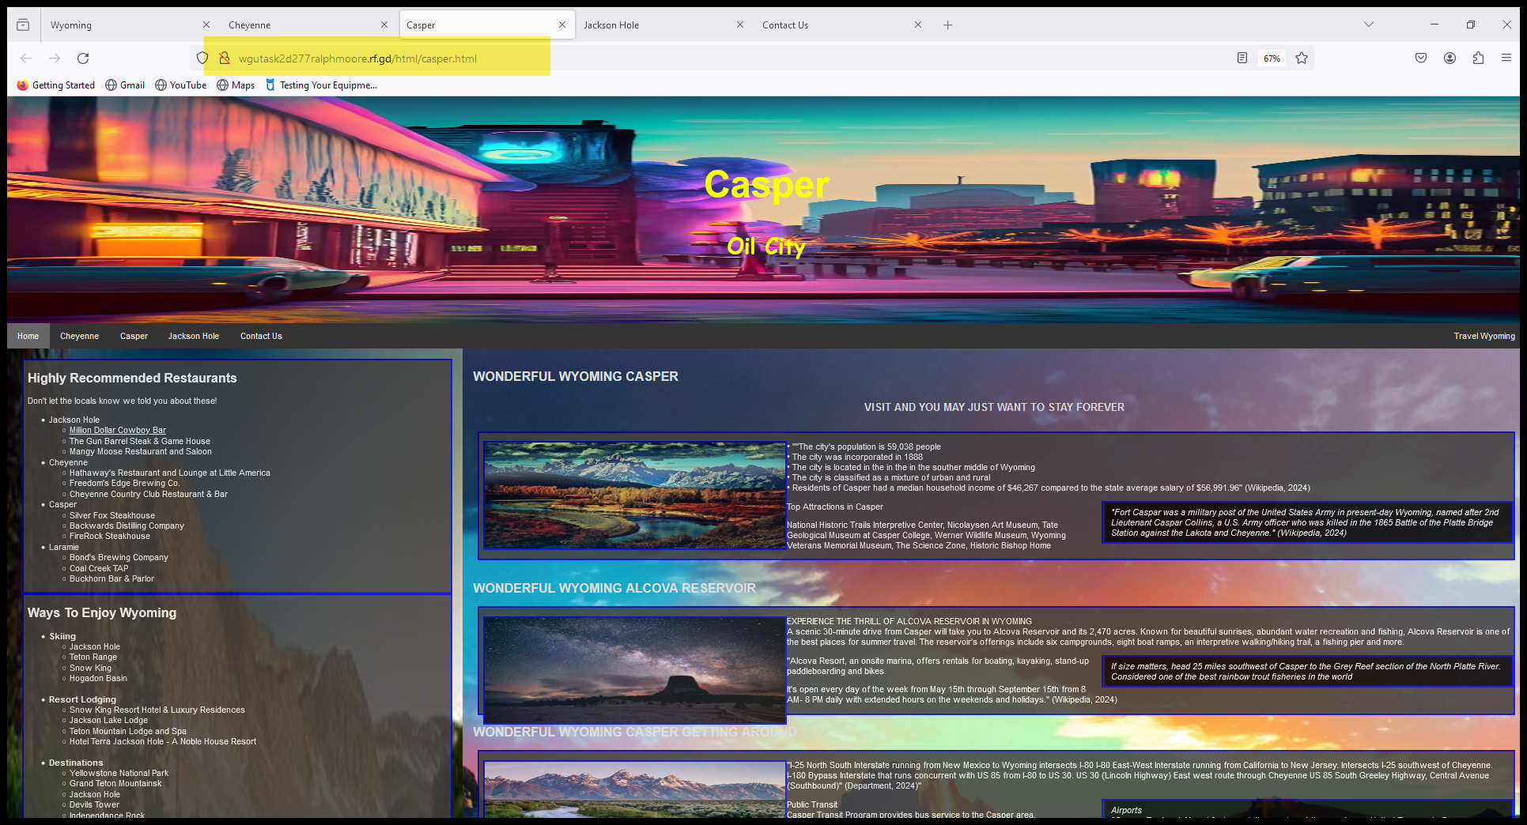

1. **Jackson Hole**

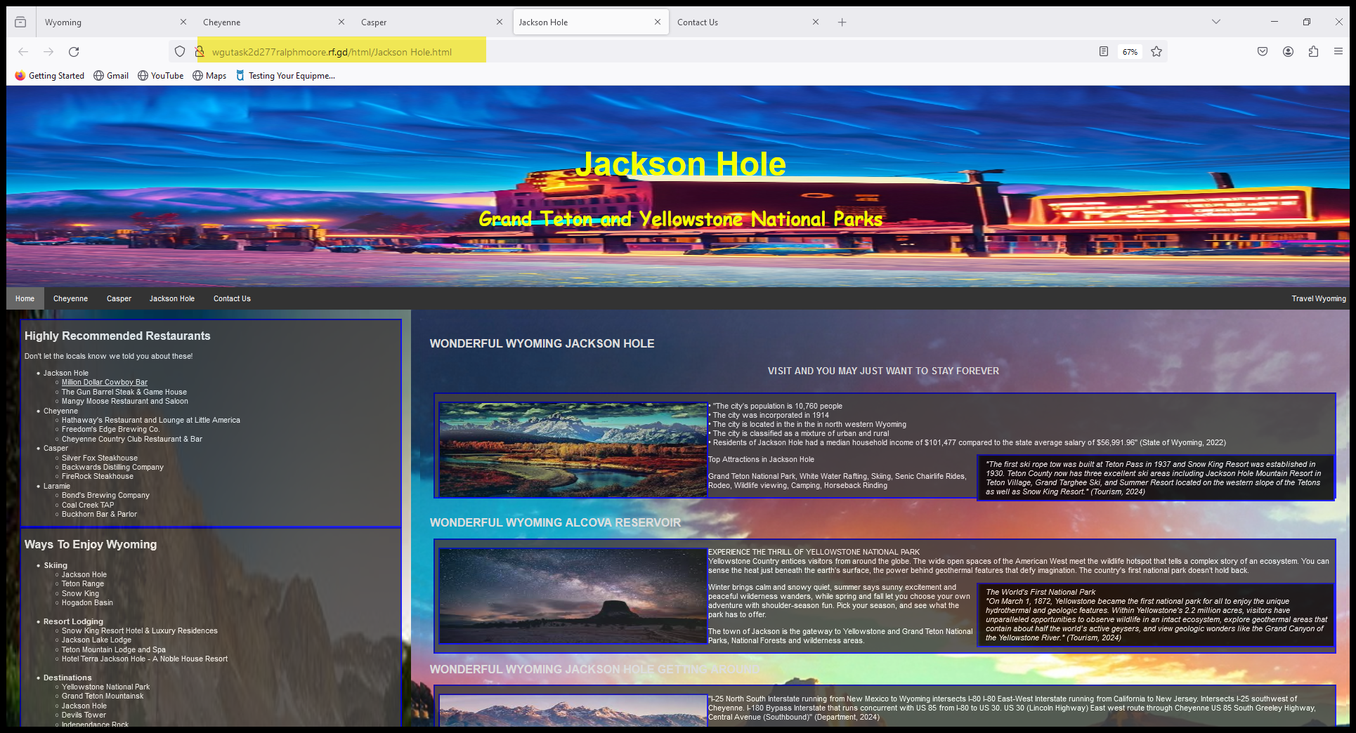

1. **Contact Us**

